Description: cid:image001.gif@01CC84D9.A29C3E60

**murleigh retail estates**

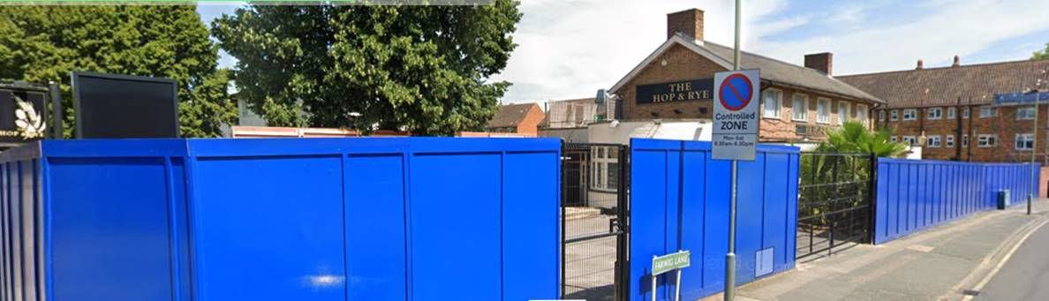

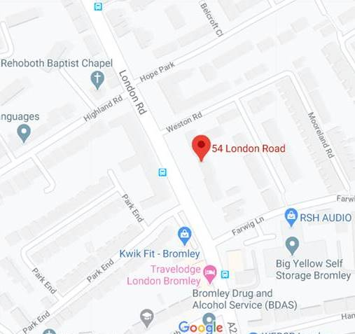

**Former Public House 54 London Road Bromley BR1 3RD**

Community Uses Only (STP)

**Location**

The property is located on busy London Road in Bromley opposite kwik Fit and adjacent to Yellow Storage.

**Property**

The property is presently laid out as a public house at ground floor extending to around 3000 Sq. Ft and a manger’s flat at first floor and a commercial Kitchen.

There is some limited-on site car parking**.**

**Tenure**

New Full Repairing and Insuring Lease for a minimum term of 15 years subject to upward only rent reviews at the end of each fifth year at a commercial rental to be agreed.

*A Freehold sale may possibly be considered.*

**Planning**

The property presently benefits form A4 uses under the Town and Country (use classes) order .

**Rates**

Interested parties should make their own enquiries of the Rateable authority.

Further Information contact to include floor plans:

Angus Maclean

Tel: 0203 005 3236

Mob: 07773 786196

[angus@mretail.co.uk](mailto:angus@mretail.co.uk)

|  |  |  |
| --- | --- | --- |
| **SUBJECT TO CONTRACT**  **1 March 2020** |  |  |

Murleigh Retail Estates LLP for themselves and for vendors/lessors of any property give notice that:

1. Any set out in correspondence or marketing material or plans is for the general outline guidance of the intended purchasers or lessees, and do not constitute, nor constitute part of, an offer or contract.
2. All descriptions, dimensions, reference to condition and necessary permissions for use and occupation, and other details are given without responsibility and any intending purchasers or tenants should not rely on them as statements or representations of fact but must satisfy themselves by inspection or otherwise as to the correctness of each of them.
3. No person at Murleigh Retail Estates LLP has any authority to make or give any representation or warranty in relation to any given property.